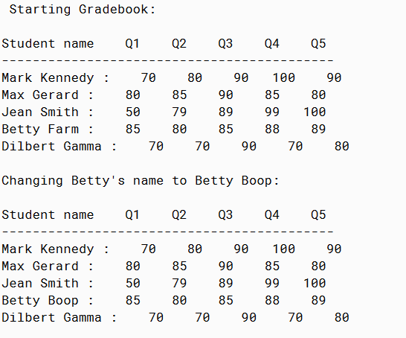

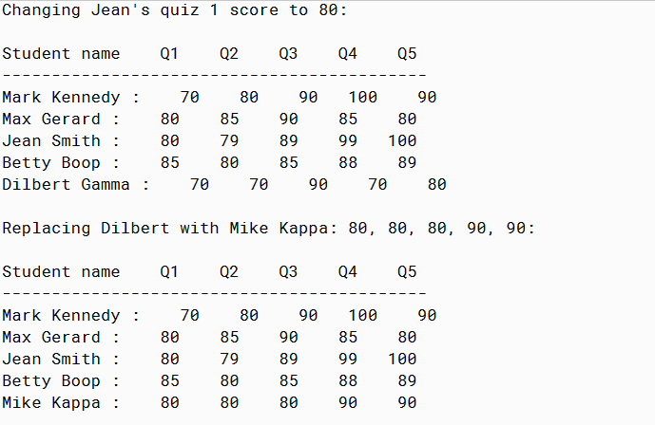

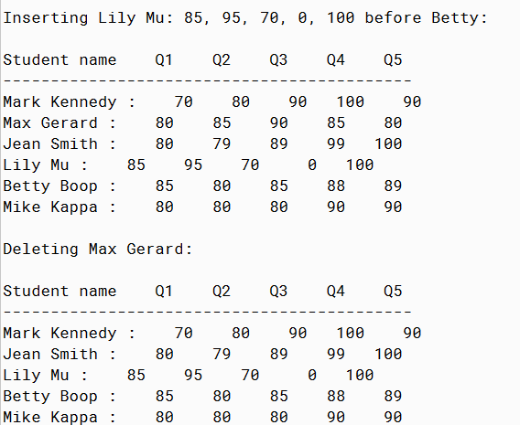

PMR: This program was easy since it was very similar to the past two assignments we had. Also there was only one main code and one tester to create so it was a fast assignment to finish. I enjoyed doing this assignment since with referral to the past assignments it was even easier.

/\*\*

\* Student interface (not technically an interface)

\*

\* @author Anika Jallipalli

\* @version 4/5/2020

\*/

import java.util.\*;

public class Student

{

private String name;

private int qz1;

private int qz2;

private int qz3;

private int qz4;

private int qz5;

public Student(String name, int qz1, int qz2, int qz3, int qz4, int qz5)

{

this.name = name;

this.qz1 = qz1;

this.qz2 = qz2;

this.qz3 = qz3;

this.qz4 = qz4;

this.qz5 = qz5;

}

public int getQuiz(int numqz)

{

if(numqz == 1)

{

return qz1;

}

else if(numqz == 2)

{

return qz2;

}

else if(numqz == 3)

{

return qz3;

}

else if(numqz == 4)

{

return qz4;

}

else if(numqz == 5)

{

return qz5;

}

return 0;

}

public void setQuiz(int numqz, int score)

{

if(numqz == 1)

{

qz1 = score;

}

else if(numqz == 2)

{

qz2 = score;

}

else if(numqz == 3)

{

qz3 = score;

}

else if(numqz == 4)

{

qz4 = score;

}

else if(numqz == 5)

{

qz5 = score;

}

else

{

System.out.println("ERROR WRONG QUIZ NUMBER");

}

}

public String getName()

{

return name;

}

public int getQz1()

{

return qz1;

}

public int getQz2()

{

return qz2;

}

public int getQz3()

{

return qz3;

}

public int getQz4()

{

return qz4;

}

public int getQz5()

{

return qz5;

}

public String toString()

{

String printme = String.format("%-1s %s %5d %5d %5d %5d %5d \n", getName(),":",getQz1(),getQz2(),getQz3(),getQz4(),getQz5());

return printme;

}

public void replaceName(String newname)

{

name = newname;

}

public void replaceQuiz(int qznum, int newscore)

{

setQuiz(qznum, newscore);

}

public void replaceStudent(String newname, int q1, int q2, int q3, int q4, int q5)

{

name = newname;

qz1 = q1;

qz2 = q2;

qz3 = q3;

qz4 = q4;

qz5 = q5;

}

}

/\*\*

\* Run the student grade program

\*

\* @author Anika Jallipalli

\* @version 4/5/2020

\*/

import java.util.\*;

public class TestStudent

{

public static void main(String[] args)

{

//start original results

System.out.println("Starting Gradebook:");

System.out.println();

ArrayList<Student> myClass = new ArrayList<Student>();

Student mark = new Student("Mark Kennedy",70,80,90,100,90);

myClass.add(mark);

Student max = new Student("Max Gerard",80,85,90,85,80);

myClass.add(max);

Student jean = new Student("Jean Smith",50,79,89,99,100);

myClass.add(jean);

Student betty = new Student("Betty Farm",85,80,85,88,89);

myClass.add(betty);

Student dilbert = new Student("Dilbert Gamma",70,70,90,70,80);

myClass.add(dilbert);

printBook(myClass);

//end of original results

//replaced name results

System.out.println();

System.out.println("Changing Betty's name to Betty Boop:");

betty.replaceName("Betty Boop");

System.out.println();

printBook(myClass);

//replace quiz results

System.out.println();

System.out.println("Changing Jean's quiz 1 score to 80:");

jean.replaceQuiz(1, 80);

System.out.println();

printBook(myClass);

//replace student results

System.out.println();

System.out.println("Replacing Dilbert with Mike Kappa: 80, 80, 80, 90, 90:");

dilbert.replaceStudent("Mike Kappa",80,80,80,90,90);

System.out.println();

printBook(myClass);

//insert new student

System.out.println();

System.out.println("Inserting Lily Mu: 85, 95, 70, 0, 100 before Betty:");

insertStudent(myClass, "Betty Boop", "Lily Mu", 85, 95, 70, 0, 100);

System.out.println();

printBook(myClass);

//delete a student

System.out.println();

System.out.println("Deleting Max Gerard:");

deleteStudent(myClass, "Max Gerard");

System.out.println();

printBook(myClass);

}

public static void printBook(ArrayList<Student> classScores)

{

System.out.printf("%s %5s %5s %5s %5s %5s \n","Student name","Q1","Q2","Q3","Q4","Q5");

System.out.println("-------------------------------------------");

for(Student t : classScores)

{

System.out.print(t.toString());

}

}

public static void insertStudent(ArrayList<Student> classlist, String find, String newname,

int q1, int q2, int q3, int q4, int q5)

{

int location = 0;

for(int i=0; i<classlist.size();i++)

{

if(classlist.get(i).getName().equals(find))

{

location = i;

break;

}

}

classlist.add(location, new Student(newname, q1, q2, q3, q4, q5));

}

public static void deleteStudent(ArrayList<Student> classlist, String find)

{

int location = 0;

int i;

for(i=0;i<classlist.size();i++)

{

if(classlist.get(i).getName().equals(find))

{

location = i;

break;

}

}

if(i != classlist.size())

{

classlist.remove(location);

}

}

}